Activities & Ministries

Directory

2016 - 2017
ADVENT EVANGELICAL LUTHERAN CHURCH

3660 Kenny Road
Columbus, Ohio 43220
Phone: 614.451.3639
Fax: 614.451.0322

Email: secy@adventelc.org
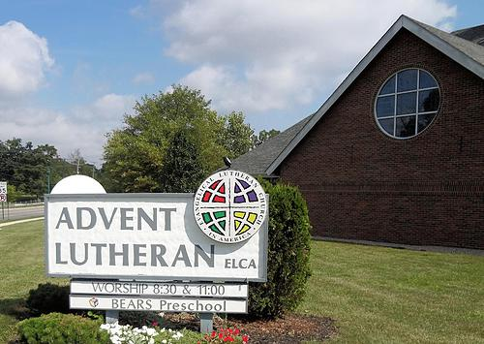
Web: www.adventelc.org

Dear Members and Friends of Advent,

The Parish Life Team welcomes you to Advent Evangelical Lutheran Church! We are delighted that there is so much interest in our ministries. We invite you to become an active member of the Advent family.

Possibilities for getting to know one another and participating in ministry are available for all ages and interests. This directory highlights our ministries, in the name of Christ at Advent Lutheran Church. Here at Advent you do not have to be a member of Advent to join with us in doing God’s work. If you have any questions about our worship services or ministries, please contact us at secy@adventelc.org.

This year we are happy to announce that at the end of the directory, page 18, there will be a new section entitled “Spiritual Gifts Assessment Tool”. This tool provides a survey online that anyone can take to identify one’s spiritual gifts. To help match one’s spiritual gifts to ministries at Advent you will find a chart on page 19.

Thanks to all who assisted in the planning, preparation, and implementation of this directory. We look forward with joy to a future filled with grace and blessing.

In peace, fun, friendship, faith, and fellowship,

The Parish Life Team: Beth Pittman (Leader), Jenn Deeter, Carl Lahman, Jeni Lahman, Matt Pittman, Bethany Rupert, Kaity Toon, Phil Toon, Katrina (Kat) Vaananen
TABLE OF CONTENTS
Page
Organization Chart . . . . . . . . . . . . . . . . . . . . . . . . . . . . . . . . . . . . . . . . 4
Church Council . . . . . . . . . . . . . . . . . . . . . . . . . . . . . . . . . . . . . . . . . . . . 5
Church Staff . . . . . . . . . . . . . . . . . . . . . . . . . . . . . . . . . . . . . . . . . . . . . . 5
Special Committees . . . . . . . . . . . . . . . . . . . . . . . . . . . . . . . . . . . . . . . . 5
Administration Team & Ministries . . . . . . . . . . . . . . . . . . . . . . . . . . . . 6
Parish Life Team & Ministries . . . . . . . . . . . . . . . . . . . . . . . . . . . . . . . . 8
Social Concerns Team & Ministries . . . . . . . . . . . . . . . . . . . . . . . . . . . 13
Worship & Witness Team & Ministries . . . . . . . . . . . . . . . . . . . . . . . . . 16
Spiritual Gifts Assessment Tool . . . . . . . . . . . . . . . . . . . . . . . . . . . . . . . 18
Matching Spiritual Gifts to Advent Ministries Chart . . . . . . . . . . . . . . 19
Labyrinth Information . . . . . . . . . . . . . . . . . . . . . . . . . . . . . . . . . . . . . . 20

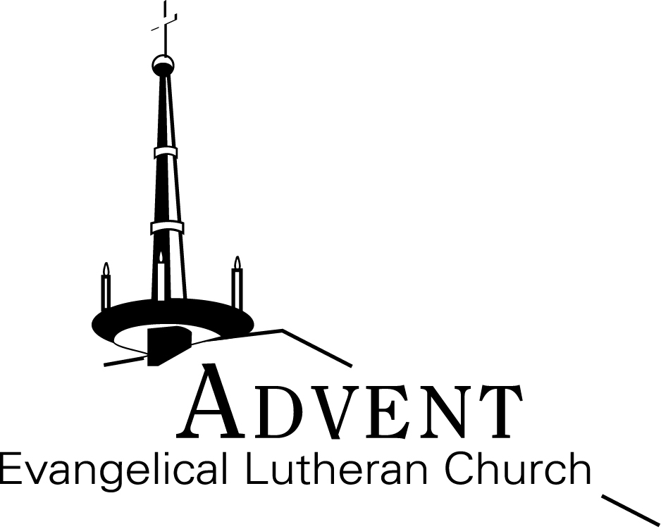

Our Mission is to:
Worship God. . .
Follow Jesus. . .
Serve others. . .
Make disciples.

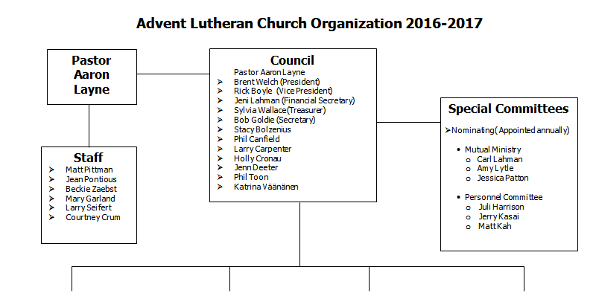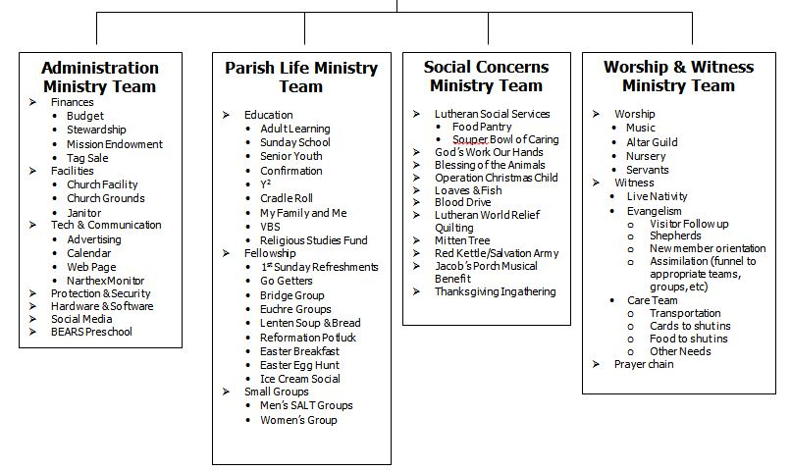
CHURCH COUNCIL
The Congregation Council oversees the life and activities of this congregation, and in particular its worship life, to the end that everything be done in accordance with the Word of God and the faith and practice of the Evangelical Lutheran Church in America. Council meets on the third Tuesday of each month at 6:30 p.m. Each council member serves as a liaison to one of the four ministry teams and attends that team’s meetings. Each council member serves a two-year term. Council members may run for another term, but no more than three full terms consecutively. Their term begins at the close of the annual meeting at which they are elected. Please refer to our church constitution for more information about the duties of council (see church Administrative Assistant for a copy).

CHURCH STAFF

Reverend Aaron M. Layne Pastor pastor@adventelc.org
Jean Pontious Dir. of Music Ministries jean.pontious@gmail.com
Matt Pittman Dir. of Youth & Family Ministries matpitt@yahoo.com
Mary Garland Administrative Assistant secy@adventelc.org
Beckie Evans-Zaebst Volunteer Coordinator beckierez@aol.com
Larry Seifert Custodian LGSeifert@yahoo.com
Courtney Crum Nursery Attendant

See website, www.adventelc.org , for descriptions of each position and a short biography of staff.

SPECIAL COMMITTEES

Nominating
The nominating committee is typically comprised of three members, at least two members from council and one may come from the congregation at large. Their task is to present names to council be considered for election by the congregation. Annually this committee is appointed. The term of service on this committee shall expire after completion of its assigned duties.

Mutual Ministry
The mutual ministry committee is comprised of three voting members of the congregation and the Pastor. Their task is to serve as support to the Pastor and as sounding board to the congregation and staff. The Council President and the Pastor shall appoint the membership of this committee jointly. Members of this newly established team will serve two years.

Personnel
The personnel committee is comprised of three voting members of the congregation and the pastor. Their task is to manage personnel matters. The Council President and the Pastor shall appoint the membership of this committee jointly. Members shall serve for three years, with a new member appointed each successive year.
See church organization chart on page 4 for a list of who currently serves on council and committees.
ADMINISTRATION MINISTRY TEAM

The Administration Team shall be responsible for the ministries of communications, support of lay staff, financial accounting and budget, stewardship, maintenance of property, office management and other ministries as may be determined.
Team Leader: Ed Cooper, edlcooper2@gmail.com

FINANCES

Budget
The Budget Team is comprised of council members and the Administration Team Leader. The primary purpose of this team is to prepare the operating budget each year and present their proposed budget to council for their approval, which is voted upon at the annual congregational meeting.
Treasurer: Sylvia Wallace, stevew1179@aol.com
Financial Secretary: Jeni Lahman, jlahman1350@gmail.com.

Stewardship
This team is responsible for promoting the scriptural principles of stewardship in the congregation, working to procure and use the gifts of the members according to the will of our Lord. The committee plans and implements the annual stewardship campaign to encourage pledging.
Team Leader: Robert Goldie, rgoldie74@gmail.com

Mission Endowment
The purpose of this fund is to enhance the mission of Advent apart from the general operation of the congregation. The fund distributions are special mission mini projects. Example would be projects within Advent, mission outreach within the community, missions of the ELCA, capital improvements, and debt reduction created as a vehicle to encourage and facilitate planned giving and to the stability and future of the church.
Treasurer: Sylvia Wallace, stevew1179@aol.com
Financial Secretary: Jeni Lahman, jlahman1350@gmail.com

Tag Sale
Every year in June, Advent has its annual tag sale. The first tag sale held was 2003. Since then the tag sale has grown to be an important event, not only for the ministries of Advent, but also to serve the community. The tag sale is also a major community recycle/reuse effort! In addition, local area residents, some of limited means, have a chance to get needed household items at a much reduced rate. Our Tag Sale Team has also proven to be a valuable resource for those families in the church struggling with what to do with left over items from an estate sale. Our Tag Sale Team can come and pack items that a family no longer wants. These items are then donated to the tag sale. Finally, all items left after the tag sale are given to the VOA (Volunteers of America). This is a yearlong project. Please refer to Advent’s website for ways to contribute.
Ministry Leader: Carl Lahman, carllahman@gmail.com

FACILITIES

Property Team
The property team oversees the care and maintenance of the church property and duties include upkeep of the church grounds, maintenance of the heating and cooling systems, organizing clean-up days, landscaping, mowing, general maintenance, and overseeing the janitorial duties.
Ministry Leader: Ed Cooper, edlcooper2@gmail.com

TECHNOLOGY & COMMUNICATION
There are a variety of ways Advent uses to communicate our mission and ministry, to our members and to the community (including: church website, email, YouTube, Google Calendar, Twitter, Instagram blogs, E-Herald, narthex monitor and press releases). Advent also has online software that allows members to view their giving patterns.
Administrative Assistant: Mary Garland, secy@adventelc.org

BEARS Preschool
B.E.A.R.S. [Beginning Education and Readiness School] is a preschool that Advent has partnered with to provide a ministry for the community. Their mission is to provide an early childhood education and development to children between 2 ½ and 5 years of age in a professional and loving Christian setting.
For more information, please visit www.bearspreschool.org, or call (614) 326-BEAR (2327)

PARISH LIFE MINISTRY TEAM

The Parish Life Team shall be responsible for the ministries of: assimilation, youth, learning, fellowship, small groups and other ministries as may be determined. This team meets on the second Monday of the month at 7:00 p.m.
Team Leader: Beth Pittman, bpmezzo@gmail.com

EDUCATION

Christian Education is at the very heart of the church. In the educational process, the Spirit of God encounters people of all ages so that they are nurtured in faith, grow in knowledge and experience, and are inspired and empowered to live as disciples of Jesus Christ.

Adult Sunday School
Adult learning meets during the Sunday School hour at 9:45 a.m. on Sunday mornings. A variety of topics will be explored during the year. Please refer to Advent’s website, http:www.adventelc.org [click on the FOLLOW Jesus tab, then click on the Christian Education tab], for a current listing of topics.
Leader: Pastor Aaron Layne, pastor@adventelc.org

Sunday School
Sunday School is available for preschool through high school at 9:45 – 10:45 a.m. on Sundays during the school year. During the summer, we do not have Sunday School, but will always begin again in the fall on Rally Day. Join us every Sunday morning for great fun, fellowship and faith! We learn about God and God’s Word in the Bible in many different ways. We follow the liturgical year so that the lessons connect with each Sunday’s worship.
Sunday School Superintendents: Jean Pontious, jean.pontious@gmail.com
Anne Pforsich, anne@pforsich.net

Senior High (9th – 12th grades)
Advent’s youth participates in many activities in three categories: service, devotion, and fun. The youth group meets at 5:30 – 7:30 p.m. on selected Sunday evenings; plus various other times for additional activities. Activities include: Swoop-In Service Days, ELCA National Youth Gatherings, Cedar Point Trips, ski trips, preparation of dinners for Jacob’s Porch Campus Ministry, Loaves and Fish (provide meals for the needy in the Columbus area), and mission trips to various parts of the country.
Leader: Director of Youth and Family Ministries: Matt Pittman, matpitt@yahoo.com

Confirmation
The Confirmation Class includes those 6th - 8th graders who are involved in a process of Bible Study, Discipleship, and Service. At the end of these three years, the students decide for themselves if they want to make public AFFIRMATION of the BAPTISM. In other words, they decide to take on their faith as their own and publicly state that they believe in Jesus Christ as their Savior and Lord.

They have a lot of fun as they learn about the Bible, Luther’s Small Catechism, and discipleship. All students are expected to be at worship on a regular basis. They meet every Sunday night from 5:30 – 7:30 p.m.; from 5:30 – 6 p.m., parents of the group provide a meal. From 6-7 p.m. is the learning time. From 7-7:30 p.m., they have fun and play crazy games.
Leader: Pastor Aaron Layne, pastor@adventelc.org

Y² – Young Youth Group
Young Youth, better known as Y², meets on a Wednesday night, from 6:30-8:00 p.m., once a month. During this time, the youth gets to know each other, play games, and have a lot of fun! They learn about God and how He exists in their everyday lives. The Y² group is also involved in projects of service.
Leader: Director of Youth and Family Ministries: Matt Pittman, matpitt@yahoo.com

Vacation Bible School
Each summer, Advent offers a week of Vacation Bible School, from 9 11:30 a.m., for ages 3 – Grade 5. This ministry has proven to be very successful and is looked forward to by Advent and the community.
Leader: Director of Youth and Family Ministries: Matt Pittman, matpitt@yahoo.com

Cradle Roll
This ministry keeps the church connected with families that have infants and young children, up to age 2, through periodic mailings and “surprises”. What a wonderful way to help our congregation’s children grow in faith from the very start!
Ministry Leader: Sarah Johanson, sarahjohanson85@gmail.com

My Family and Me (Preschool and K)
This group of young children and parents meets quarterly for activities, crafts and typically with a Biblical theme relating to the time of the year.
Ministry Leader: Karrie Clark, karriejclark@gmail.com

Religious Studies Fund
The Religious Studies Fund was created to ensure continual resources for seminarians to serve as the future leadership of the ELCA. This fund is a line item in Advent’s Budget and the yearly amount can vary, based upon recommendations from the Parish Life Team. Currently, Advent supports one seminarian. However, in the future, this could change and based upon the number of seminarians, the available funds could be split equally. The ELCA also has a program called Young Adults in Global Mission, which invites ELCA young adults into a transformative, yearlong journey in international service. This may be a future opportunity for someone in our congregation, to become the hands and feet of Jesus in the world. Contact person: Pastor Aaron Layne, pastor@adventelc.org

SMALL GROUPS

Men’s SALT
S.A.L.T. is an acronym for Sharing and Living/Learning Together. The purpose of this ministry is to bring men together in fellowship so they can grow in their understanding of Christ, get to know each other better and develop deeper relationships. Currently this group meets twice a month (except not during the summer).
Ministry Leaders:
George Zaebst, gzaebst@gmail.com; Carl Lahman carllahman@gmail.com

Women’s Bible Study
This group meets monthly, every 2nd Thursday at 1 p.m. currently using “Daily Discipleship”, which is an ELCA online downloadable Bible study based on the lectionary used at Sunday worship. Additional resources include the devotional “Christ in Our Home”.
Ministry Leader: Jeni Lahman, jlahman1350@gmail.com

FELLOWSHIP

1st Sunday Refreshments
Advent offers coffee and conversation in between the two services on a weekly basis, but the first Sunday of every month is special – lots of goodies! Advent’s Parish Life Team supplies the doughnuts and congregation members bring their specialties, as well. Everyone is welcome to share in the food and fellowship.
Ministry Leader: Beth Pittman, bpmezzo@gmail.com

Go Getters
This group is an energetic group of Empty Nesters, Singles and Retirees on the quest to find the best pizza (and other foods) in the Columbus area. This group meets monthly at local restaurants for fun, food and fellowship. It is a great way to meet other Advent members in a casual environment. Guests are welcome.
Ministry Leader: Sandra Carpenter, larrycsandrac@yahoo.com

Bridge Group
Do you like to play bridge but hate it when people get upset with a bad bid? This is the group for you. We are a FRIENDLY bridge group which meets on Monday afternoons at 1:30 p.m. in the church Narthex. All skill levels are welcome from beginner to long time player. There is always fun and fellowship and of course – grace and forgiveness. This is contract bridge at its best!!
Ministry Leader: George Zaebst, gzaebst@gmail.com

Euchre Groups
There are currently three euchre groups. The three existing groups meet once a month to eat, socialize, and play cards. Three tables of four players play with rotating partners, according to this schedule:
Group 1 meets at 6:30 p.m. on the 3rd Friday all year long. Snacks are shared.
Group 2 meets at 7:00 p.m. on the 2nd Friday (not during the summer). Meals are shared.
Group 3 meets at 6:30 p.m. on the 1st Monday of each month.
Ministry Leader for Group 1: Chuck Graver, chuckphyllis6460@aol.com
Ministry Leader for Group 2: Becky Beck, tweetybb14@yahoo.com
Ministry Leader for Group 3: Christy Habermehl, Christy.habermehl@gmail.com

Lenten Soup Suppers
All are invited to the Lenten Soup Suppers. Every Wednesday during Lent, Advent hosts a simple supper of soup and bread before a mid-week Lenten evening prayer service. The suppers start the week after Ash Wednesday and continue until Holy Week, and they begin at 6:30 p.m., with the service following at 7:15 p.m. Sign-up sheets are made available in the Narthex for those who would like to sign up to bring soup or bread to share.
Contact: Parish Life Team
Reformation Potluck
Advent hosts a potluck dinner every year on Reformation Sunday, typically the last Sunday in October, to celebrate the anniversary of Martin Luther nailing the “95 Theses” upon the church doors. Everyone is welcome, and those who are able, are encouraged to bring a dish to share.
Contact: Parish Life Team
Easter Breakfast
Easter Breakfast is served each year in between the services on Easter Sunday morning. The church provides ham and beverages, and people are encouraged to bring their favorite breakfast/brunch dishes to share. All are invited and welcome at this festive affair! Ministry Leader: Pam Kasai, pamkasai@columbus.rr.com

Easter Egg Hunt
The Easter Egg Hunt takes place on the Saturday morning before Easter, and all children between the ages of 1 year through 4th grade are invited to participate. The event starts with crafts and a story about the meaning of Easter, and culminates with members of the Advent youth groups leading the participants to the hunting grounds.
Ministry Leader: Andrea Lusk, alusk@uaschools.org

Ice Cream Social
Each summer everyone is invited to an Ice Cream Social, typically on a Sunday, beginning at 4:00 pm. Included are light refreshments of finger food and drinks before the main course of HOMEMADE ICE CREAM!
Contact: Parish Life Team

SOCIAL CONCERNS MINISTRY TEAM

The Social Concerns Team shall be responsible for the ministries of: social outreach, Christian care, overall witness and other ministries as may be determined. This team meets on the second Tuesday of the month at 7:00 p.m.
Team Leaders: Jennifer Parker, akajp@rocketmail.com
Allan MacDonald, allanmac00@gmail.com

LSS Food Pantry – Champion Ave.
Lutheran Social Services has been providing food to families in need since 1927, and today is one of the largest single direct providers in Central Ohio. Last year pantries served more than 2 million meals. LSS strives to provide nutritious food in an atmosphere of kindness, dignity and respect. We, at Advent, help by collecting non-perishable goods and working four hours at the Champion Avenue Food Pantry on the third Saturday of the month. Pantry workers stock shelves and help patrons shop. We hope you will consider volunteering one Saturday a month or being part of our substitute list.
Ministry Leader: Elaine Cooper, edlcooper2@gmail.com

Loaves and Fish Ministry
Advent Loaves and Fish teams partner with the Salvation Army in Worthington (using their kitchen and canteen truck) providing meals for the needy in the Columbus area. We are scheduled to work the second Sunday, every other month (i.e., six times a year). The work is divided among three teams. Food preparation begins at 2:00 p.m. and loading the food truck begins at 4:15 p.m. and ends approximately 7:00 p.m. There are three stops where food and donated items (i.e., socks & underwear) are distributed. Please consider joining a team or being part of our substitute list.
Ministry leader: Randy Patton, randy.patton1@gmail.com

American Red Cross Blood Drive
Twice a year on a Sunday a blood drive is scheduled at Advent. The actual blood donation typically takes less than 10-12 minutes. The entire process, from the time you arrive to the time you leave, takes about an hour and 15 minutes. You can be someone’s hero – in fact, you could help save more than one life with just one donation. To learn more about the blood donation process please visit http://www.redcrossblood.org/donating-blood. Ministry leaders: Stacy Bolzenius, stacyrb@rrohio.com
Allan MacDonald, allanmac00@gmail.com.

Thanksgiving Ingathering
Each November, Advent members are provided with a shopping list of specific items related to a Thanksgiving dinner. Bags of these items are brought to Advent and then transported to the LSS Food Pantry on Champion Ave. for distribution. Each bag is designed to feed a family of four. Cash donations by members are used to buy additional bags. Whole chickens and butter are also purchased to supplement the bags of groceries. This enables the less fortunate to truly be thankful on Thanksgiving Day.
Ministry Leader: Larry Seifert, LGSeifert@yahoo.com.

Blessing of the Animals
Annually, Advent has a “Blessing of the Animals” service on the first Sunday of October. It is a special outdoor service of thanksgiving and prayer for the living treasures of God’s good creation. All animals and their human companions are invited. In the past, other Lutheran congregations have joined us. As there continues to be a real need for cat and dog food assistance at the local LSS food pantries, we ask those attending the service, as well as members of the congregations, to bring a bag or can of cat or dog food. Our donations are greatly appreciated.
Ministry Leader: Jennifer Parker, akajp@rocketmail.com.

God’s Work, Our Hands
This is an ELCA worldwide 2-day event. ELCA members are called to put their faith into action by engaging in service activities in their neighborhood and surrounding community. Here at Advent, the Social Concerns Team helps organize a number of projects each year such as collecting school supplies for children in need, preparing and distributing Blessing Bags for the homeless, stocking shelves at LSS, landscaping or other projects at Jacob’s Porch (a campus ministry at OSU), disaster response projects, cards for military men and women, and visiting nursing homes. Please prayerfully consider being part of this opportunity to “serve others”.
Ministry Leader: Social Concerns Team

Isabel’s Quilters
Each year dedicated quilters across the US donate an average of 400,000 quilts to LWR (Lutheran World Relief). These quilts provide warmth in the form of bedding, shelter in the form of a roof, privacy in the form of a door. They also serve as a tangible reminder of God’s presence, love, and hope. Do not be intimidated! These quilts are not the same as the hand-stitched heirloom quilts your grandmother made. All men, women and children can easily get involved. Ministry Leader: Jeni Lahman, jlahman1350@gmail.com

Mitten Tree
Each December a small-undecorated Christmas tree is placed in the Narthex. Children’s hats, gloves and mittens are donated by Advent members, hung on the tree and subsequently donated to middle school students who are in need of warm accessories during the winter months. All sizes and types of hats, gloves and mittens are appreciated.
Ministry Leader: Jennifer Parker, akajp@rocketmail.com.

Red Kettle/Salvation Army
Advent volunteers to staff a RED KETTLE for the Salvation Army each year. Members sign up for one hour shifts to ring bells, sing carols or just greet people as they enter a local Kroger store at Christmas (actually Advent) time. Others volunteer an evening to count money at the Salvation Army headquarters downtown Columbus.
Contact: Social Concerns Team

Operation Christmas Child
This endeavor, sponsored by Samaritan’s Purse, is part of the world’s largest Christmas project of its kind. Operation Christmas Child uses gift-filled shoeboxes to share God’s love in a tangible way with needy children around the world. By packing a shoebox filled with small toys, hygiene items, and school supplies, we too can demonstrate God’s love to a child in need. Ministry Leader: Allan MacDonald, allanmac00@gmail.com.
SOUP-ER Bowl
Pick a side. We are not talking about NFL teams. Choose a side of the church to sit on, on a Sunday morning. We are literally split down the middle to see how much money and food we can donate to LSS Food Pantries. Winning side gets bragging rights!
Ministry Leader: Pastor Aaron, pastor@adventelc.org.

Jacob’s Porch Musical Benefit and Art Auction
Jacob’s Porch is a campus ministry for OSU students. To support this ministry, Advent has on occasion sponsored a musical and art auction benefit. All proceeds go to support the campus ministry at Jacob’s Porch to help keep this ministry growing.

WORSHIP AND WITNESS MINISTRY TEAM

The Worship and Witness Team shall be responsible for the ministries of: worship and music, member and visitor outreach and evangelism, and other ministries as may be determined. This team meets on the fourth Monday of the month at 6:00 p.m.
Team Leader: Becky Seifert, seifertbecky@yahoo.com

WORSHIP

Music
Music Ministries encompasses many different groups at Advent, including worship music, Advent Angels (young children’s choir), youth choir, adult choir, and hand bells. The Dream Team is a song and dance troupe for children 1st – 5th graders, which helps lead openings and closings during Vacation Bible School.

Director of Music Ministries Jean Pontious jean.pontious@gmail.com
Organist Jean Pontious jean.pontious@gmail.com
Adult Choir and Bell Director Matt Pittman matpitt@yahoo.com
Advent Angels/ Youth Choir Jean Pontious jean.pontious@gmail.com
Vacation Bible School Dream Team Matt Pittman matpitt@yahoo.com

Servants
Worship Teams coordinate the Lord’s Servants, sets of volunteers who perform a variety of important tasks during Sunday morning worship services. Here are some of the positions coordinated by these teams:
Worship Team Leader: Responsible for assigning duties for his/her team.
Acolyte: Lights candles, assists during the Offering. (May serve as crucifer)
Reader: Reads the first and second scripture readings.
Communion Assistants: Assists with Communion.
Gifts of Bread and Wine: Presents the bread and wine to the Communion table.
Greeters: Welcome everyone as they come to worship.
Ushers: Hand out bulletins and assist during the Offering and Communion.
Crucifer: Carries the cross to and from the altar. (Usually the Acolyte)
Sound Crew: Handles sound levels and video recording during worship.
Assisting Minister: Presents parts of the liturgy during worship.

Nursery
For children ages 5 years and under, Nursery service is available during both Sunday Worship Services, as well as during Sunday School and special occasions. A paging system is available for parents.
Nursery Attendant: Courtney Crum

Altar Guild
The overall purpose of the Altar Guild is to see that the worship space is kept beautiful and in good order, both to glorify God and to provide a setting which enables the congregation to worship in a meaningful way. There are many responsibilities of Altar Guild in preparing the setting for corporate worship.
Ministry Leader: Beckie Evans-Zaebst, beckierez@aol.com

WITNESS

Evangelism
Evangelism occurs at many different levels, from showing hospitality to guests to coordinating visitation to first time worship guests. It also provides programs for inviting new members into the congregation. Evangelism also includes visitation ministries and community outreach. Ministry Leader: Norma Pitts, npitts@columbus.rr.com

Live Nativity
The annual Live Nativity is a popular December event at Advent for the community. This ministry involves live animals, “actors” dressing as Biblical characters, live music, luminaries, readings of the Christmas story, singing of hymns and carols, refreshments, and fellowship; as we provide a live nativity scene, on our front lawn, for all to see.
Leader: Director of Youth & Family Ministries: Matt Pittman, matpitt@yahoo.com.

Care Team
Members of the Care Team are available to assist Pastor with hospital, nursing home and home visitation. They also may help to meet the acute and ongoing needs of those in crisis through such activities as preparing meals, providing transportation and making phone calls of care. Meal baby program assists families with new infants. Ministry Leaders: Betty Appell, bappe4374@gmail.com;
Marti Schorr, masch4374@aol.com.

PRAYER CHAIN

The Advent Prayer Chain enables communication regarding needs among members and friends of Advent through e-mail. All prayer requests are welcomed.
Administrative Assistant: Mary Garland, secy@adventelc.org

Spiritual Gifts Assessment Tool
To find your spiritual gifts, please go to the ELCA website at https://www.elca.org/en/Our-Work/Congregations-and-Synods/Faith-Practices/Spiritual-Renewal/Assessment-Tools
The Spiritual Gifts Assessment tool is a quick survey you can take to identify your spiritual gifts. After you have completed the survey, you will receive a document highlighting your spiritual gifts.
Once you have identified your spiritual gifts, please take time to match your spiritual gifts to the many ministries at Advent listed in the following Matching Spiritual Gifts to Advent Ministries Chart. Keep in mind that this chart is simply a guide.
When you find a ministry that matches your spiritual gift, please refer back to your Activities & Ministries Directory and find the contact person under that ministry. The ministry leader will be able to answer questions you may have and help you on how to get involved with a particular ministry.
Note: When browsing through the Activities & Ministry Directory, you will often find several opportunities for many of the ministries of Advent. For example, if you are interested in the ministry of “Social Concerns”, there are 12 sub-ministries that one can join and serve.

